**Verilog Lab測驗**

班級: 資工二乙

姓名: 蒲品憶

學號: 10927207

Counter

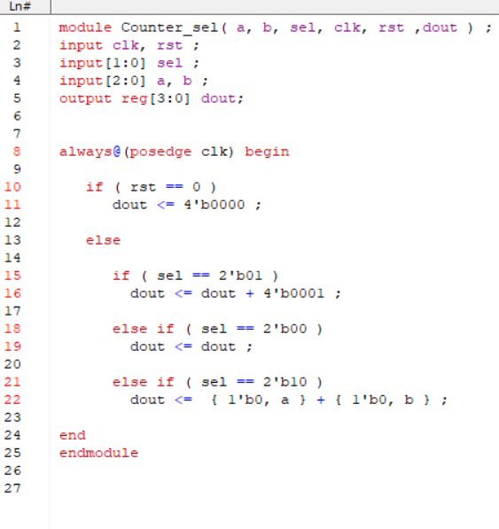

TM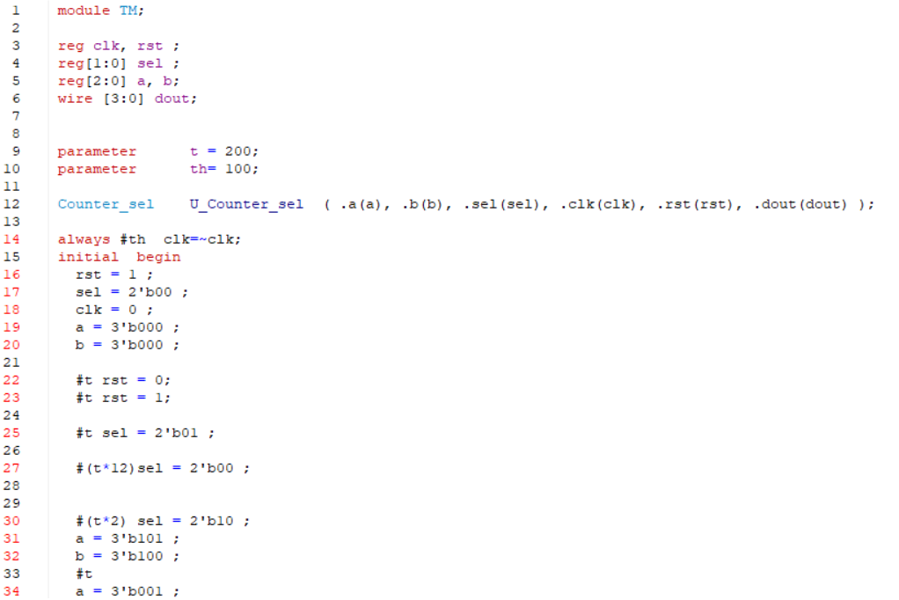

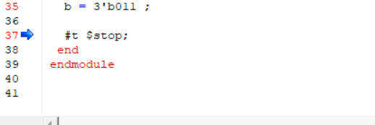

Wave

當rst = 0 時 dout = 0

當rst = 1 時

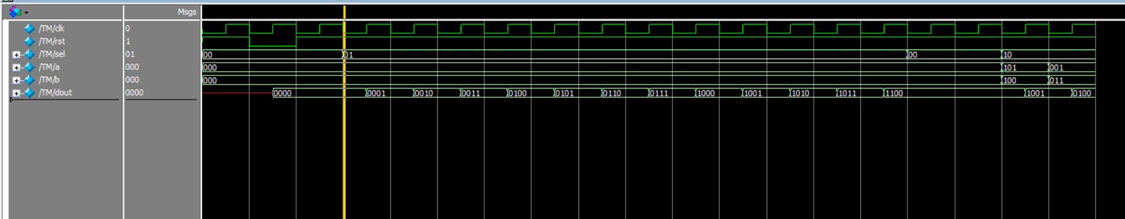

sel = 01 , dout = dout + 1

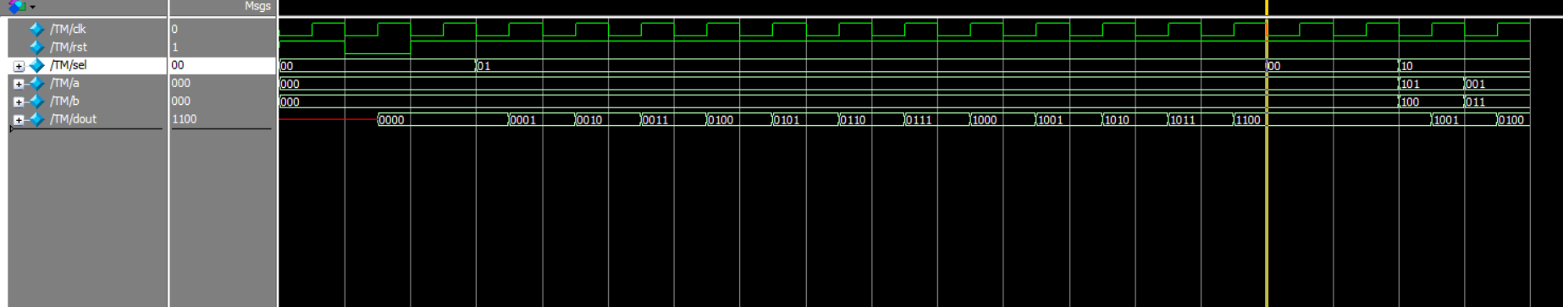

sel = 00 , dout = dout

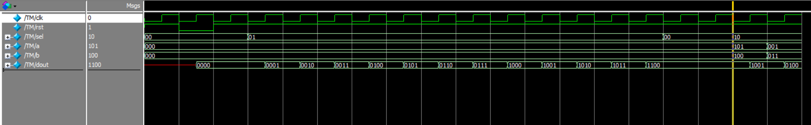

sel = 10, dout = { 1’b0, a } + { 1’b0,. b }

pwd

